1. Create a page with bookmarking.

<!DOCTYPE html>

<html lang="en">

<head>

<meta charset="UTF-8">

<meta name="viewport" content="width=device-width, initial-scale=1.0">

<title>Bookmarking</title>

</head>

<body>

<h1 id="home">welcome</h1>

<button> <a href="#Bahubali 1">Bahubali 1</a></button>

<button> <a href="#Bahubali 2">Bahubali 2</a></button>

<h1 id="Bahubali 1">Bahubali Chapter 1</h1>

<p>

Baahubali: The Beginning is a 2015 Indian Telugu-language epic action film co-written and directed by S. S. Rajamouli, and produced by Shobu Yarlagadda and Prasad Devineni under Arka Media Works. The film was produced in Tollywood and was filmed in both Telugu and Tamil languages simultaneously. It features Prabhas in a dual role alongside Rana Daggubati, Anushka Shetty, Tamannaah Bhatia, Ramya Krishna, Sathyaraj, and Nassar. The first of Duology, the film follows Sivudu, an adventurous young man who helps his love Avantika rescue Devasena, the former queen of Mahishmati who is now a prisoner under the tyrannical rule of king Bhallaladeva. The story concludes in Baahubali 2: The Conclusion.

The film's story was written by Rajamouli's father V. Vijayendra Prasad, who randomly told him a story about Sivagami, a woman who carries a baby in her hand while crossing a river, and a few years later about Kattappa, which intrigued Rajamouli. His fascination with Mahabharata and the tales of Amar Chitra Katha and Chandamama further fuelled his interest in the story. However, it took the writers three months to complete the final draft. The soundtrack and background score were composed by M. M. Keeravani, while the cinematography, production design, and VFX were handled by K. K. Senthil Kumar, Sabu Cyril and V. Srinivas Mohan respectively.

The film was made on a budget of ₹180 crore ($28 million),[b] making it the most expensive Indian film at its time of release. The film opened worldwide on 10 July 2015 along with the dubbed versions in Hindi and Malayalam. It received national and international acclaim for Rajamouli's direction, story, visual effects, cinematography, themes, action sequences, music, and performances,[9] and became a record-breaking box office success. It was also praised by the actors of the film industry and, along with its successor, is widely regarded as one of the greatest Indian epic action films.[10][11] With a worldwide box office gross of ₹600–650 crore, it became the highest-grossing Telugu film and the second highest-grossing Indian film worldwide. It is currently the fourth highest-grossing Telugu film of all time. Its Hindi dubbed version also broke several records by becoming the highest-grossing dubbed film in Hindi of all time. Both budget and box office records have since been surpassed by Baahubali 2: The Conclusion, the highest-grossing film in India of all time.

Baahubali: The Beginning became the first Indian film to be nominated for American Saturn Awards, receiving five nominations at the 42nd ceremony, including Best Fantasy Film and Best Supporting Actress. It received several accolades such as the National Film Award for Best Feature Film, and the National Award for Best Special Effects. It won five awards from ten nominations, including Best Telugu Film, Best Director - Telugu for Rajamouli and Best Supporting Actress - Telugu for Ramya Krishna respectively, at the 63rd Filmfare Awards South.

Plot

An injured woman is shown emerging from a cave underneath a huge mountain, carrying an infant. She kills two soldiers pursuing her and attempts to cross a raging river, but slips and starts getting washed away by the current. Facing imminent death, she holds the baby aloft and prays to Lord Shiva, explaining that while she doesn't care about her life, the baby, Mahendra Baahubali, must live, for the sake of Mahishmati kingdom, and the waiting baby's mother. She offers her own life as compensation for her sins. The child is saved by the people of the local Amburi tribe, who reside near the river and worship Lord Shiva. The wife of the tribe's chieftain, Sanga, decides to adopt the boy and names him Siva.

Siva grows up to be an ambitious and mischievous child, obsessed with ascending the mountain. Despite Sanga's pleas, he tries many times to scale the cliffs but always fails. As a young man, he is shown to possess superhuman strength when he lifts a Lingam of Lord Siva and places it at the foot of the mountain. A mask then falls from the cliffs, and realizing it possesses feminine features, Siva becomes obsessed with finding the owner of the mask. He finally succeeds in scaling the mountain. Upon reaching the top, he sees a dashing warrior girl named Avantika fighting soldiers. He discovers that she is a member of a local resistance group dedicated to overthrowing the tyrannical king Bhallaladeva of the nearby kingdom Mahishmati, and rescuing their captive Princess Devasena. Siva is immediately smitten with Avantika and secretly follows her. When she discovers Siva, she attacks him, but he outmaneuvers her and returns her mask, progressively disrobing her with each step. Realizing he scaled the entire mountain to find her, she reciprocates his feelings and they make love.

After discovering Avantika's cause, Siva pledges to rescue Devasena himself and departs for Mahishmati. He infiltrates the royal palace disguised as a soldier and distracts Bhallaladeva and his guards long enough for him to rescue Devasena. Bhallaladeva sends his son, Bhadra, and the royal family's loyal slave general Kattappa to recapture Devasena. In the ensuing fight, Siva beheads Bhadra as both the Amburi tribe and resistance warriors arrive. Kattappa lunges at Siva, but stops short of attacking him upon seeing his face. He falls into submission at Siva's feet, proclaiming him to be "Baahubali".

The next morning, Kattappa reveals to Siva that he is actually Mahendra Baahubali, the son of Amarendra Baahubali, a famous invincible warrior prince from Mahishmati, and that the woman who had sacrificed herself to save him was Queen Sivagami, his grandmother. Amarendra Baahubali was born an orphan; his father, King Vikramadeva, died before he was born and his mother died giving birth to him. Bijjaladeva, Vikramadeva's brother and the next in line for the throne, is denied the position due to his scheming nature, and as such Bijjaladeva's wife, Queen Sivagami, assumes power as a caretaker with the intention of raising both her son Bhallaladeva and the orphaned Baahubali in an equal manner to select the next heir to the throne. While the two are raised as brothers and trained rigorously in numerous subjects, Bhallaladeva retains the power-hungry nature of his father while the affable Baahubali becomes beloved by the kingdom.

A traitor named Saketa turns out to be a spy for the savage Kaalakeya tribe, known as destroyers of kingdoms. Their chief Inkoshi declares war on Mahishmati, and Lord Bijjaladeva decides that whoever kills Inkoshi will be crowned king. However, after Inkoshi personally insults Sivagami on the battlefield, she demands that he be brought to her alive. Bijjaladeva cunningly arranges better and sophisticated artillery weapons and men fo Bhallaladeva, but Baahubali still defeats more raiders than Bhallaladeva by using innovative tactics and by inspiring his soldiers. With Mahishmati soldiers flagging in the battle, Amarendra inspires them to not give up in the face of death while also rescuing villagers captured by the Kaalakeyas at a risk. Bhallaladeva, meanwhile, kills Kaalakeyas and villagers indiscriminately, killing Inkoshi as well. Baahubali's valour and concern for the people of his kingdom convinces Sivagami to make Baahubali the heir apparent while Bhallaladeva is made the commander-in-chief for his sheer prowess.

In the present day, Siva's adoptive parents, impressed by Kattappa's story, wish to meet Baahubali. A dejected Kattappa explains that Amarendra Baahubali is dead, stabbed behind his back by a traitor, and upon being questioned by Siva, he reveals that the traitor was none other than him

</p>

<button> <a href="#home">home</a></button>

<h1 id="Bahubali 2">Bahubali chapter 2</h1>

<p>

Baahubali 2: The Conclusion is a 2017 Indian Telugu-language epic action film directed by S. S. Rajamouli, who co-wrote the film with V. Vijayendra Prasad. The film was produced by Shobu Yarlagadda and Prasad Devineni under the banner Arka Media Works. The film was produced in Tollywood, and was filmed in both Telugu and Tamil languages simultaneously. It features Prabhas in a dual role alongside Rana Daggubati, Anushka Shetty, Tamannaah Bhatia, Ramya Krishna, Sathyaraj, Nassar, and Subbaraju. This film is the follow-up to Baahubali: The Beginning, serving as both a sequel and a prequel.[7] The film is set in medieval India and follows the sibling rivalry between Amarendra Baahubali and Bhallaladeva; the latter conspires against the former and has him killed by Kattappa. Years later, Amarendra's son returns to avenge his death.

The film was made on an estimated budget of ₹250 crore and was the most expensive Indian film at the time of its release. The production began on 17 December 2015 at Ramoji Film City, Hyderabad. The cinematography was done by K. K. Senthil Kumar, and editing was handled by Kotagiri Venkateswara Rao. The production design was done by Sabu Cyril, while the action sequences were choreographed by Peter Hein. The visual effects were designed by Makuta VFX, with assistance from Adel Adili and Pete Draper. The soundtrack and the background music were composed by M. M. Keeravani. Baahubali 2 was released on 28 April 2017 in Telugu, Tamil, Hindi, Kannada and Malayalam version and later dubbed in Japanese, Russian and Chinese. Released in conventional 2D and IMAX formats, Baahubali 2 was the first Telugu Film to also release in 4K High Definition format.

Baahubali 2 was among the most anticipated films of 2017 as the predecessor ended in a massive cliffhanger.[8][9][10][11] The film premiered on over 9,000 screens worldwide, with 6,500 of those screens in India alone, setting a new record for the widest release of an Indian film., breaking the record for the widest Indian film release.[12][13] Upon its release, it grossed ₹1737.68-1810.60 worldwide, surpassing PK (2014) to briefly become the highest grossing Indian film of all time, collecting approximately ₹789 crore worldwide within first six days of its release. It became the first-ever Indian film to gross over ₹1000 crore, in just a span of ten days. Within India, it set many film records, becoming the highest-grossing film in Hindi, as well as in its original Telugu and Tamil languages. It stands as the highest-grossing film in India till date, the highest grossing Telugu film,[14] the highest grossing South Indian film and the second highest-grossing Indian film worldwide. The film sold over 12 crore tickets during its box office run, the highest estimated admissions for any film in India since Sholay (1975).[15][16]

Baahubali 2, like its predecessor, received nationwide and universal acclaim for Rajamouli's direction, the story, cinematography, themes, visual effects, music, action sequences, acting, and emotional weight.[17] It was also praised by the actors of the film industry alike and, along with its predecessor and Rajamouli's other films, is widely regarded as one of the greatest and most influential Indian epic action-drama films.[18][19] It won the Saturn Award for Best International Film and three National Film Awards: Best Popular Film Providing Wholesome Entertainment, Best Special Effects and Best Stunt Choreographer. The Baahubali franchise pioneered Pan-Indian film movement, that is, rather than remaking the same film in various languages, they are dubbing the same film in various languages.[20]

Plot

The plot of the film connects with the predecessor. For more information on the predecessor's plot, see Baahubali: The Beginning.

Kattappa continues to narrate how he betrayed and assassinated Amarendra Bahubali. After Amarendra's triumphant victory over the Kalakeyas, he is designated as the heir to the throne, while Bhallaladeva is named the future commander-in-chief. Queen Sivagami Devi, recognizing Amarendra's potential, sends him on a tour of the kingdom in disguise with Kattappa to learn about political affairs. During their journey, Amarendra witnesses Princess Devasena of Kuntala bravely repelling attackers, leading to admiration and eventually love for her. Still in disguise, he approaches her and is accepted into the royal palace of Kuntala as a guard in training under Devasena's cousin, Kumara Varma.

Bhallaladeva gets word about Amarendra's acts and upon viewing Devasena's portrait, lusts for her and acquires a promise from Sivagami, who assures Bhallaladeva's marriage with Devasena oblivious to the fact that Amarendra has already fallen in love with her. Sivagami sends an emissary to Kuntala proposing marriage but the emissary portrays it in a patronizing way leaving Devasena enraged. She gives a scathing reply rejecting the proposal and upon receiving her response, Bijjaladeva tricks Sivagami into sending an order to Amarendra that Devasena be brought to Mahishmati as a captive.

In Kuntala, an attack by Pindari dacoits on the royal palace exposes Amarendra and Kattappa's bravery and they nullify the attack with assistance from Devasena and Kumara Varma, who overcomes his cowardice with Amarendra's encouragement. Upon being confronted when Amarendra receives the message to capture Devasena, Kattappa reveals that Amarendra is the future king of Mahishmati. Amarendra, promising Devasena that he would protect her honour at any cost, takes her to Mahishmati. In the court, the misunderstanding is brought to light and Sivagami tells Amarendra to choose between the throne and Devasena. Unwilling to break his promise to the princess, he chooses to marry her and serve the kingdom as its commander-in-chief. Bhallaladeva's coronation takes place at a grand note but he seethes with jealousy over Amarendra's popularity among citizens. Devasena soon expects a child and during her baby shower, Bhallaladeva deprives Amarendra of his commander post under pretext of making sure that Amarendra spends most of his time with his pregnant wife and the post is given to court official Sethupathi. Devasena questions the decision, declaring it unfair and confronts Sivagami for her inactions. She asks Amarendra to ascend the throne as a gift to her, leaving everyone stunned by her insolence.

During her visit to a temple, Devasena cuts Sethupathi's fingers off with a dagger when he gropes women and tries to do the same to her. She is shackled and produced in the court where Amarendra beheads Sethupathi. Both Devasena and Amarendra are banished from royal palace and decide to live as commoners. As Amarendra's fame does not decrease, Bijjaladeva and Bhallaladeva stage a conspiracy to further turn Sivagami against Amarendra. Bijjaladeva convinces Kumara Varma that Amarendra, Devasena and their unborn baby's lives shall be threatened by Bhallaladeva's evil schemes and manipulates him into entering the palace at stealth of night for assassinating Bhallaladeva to do good. However, Kumara Varma and his companions are defeated and killed. Sivagami, who believes that Kumara Varma is sent by Amarendra for murdering Bhallaladeva secretly passes an order to Kattappa for assassinating Amarendra as declaring it publicly would lead to an internal war.

Destined to be bound to the kingdom, Kattappa lures Amarendra into a secluded place feigning that he is in trouble, before backstabbing and killing him. Bhallaladeva exposes himself to Kattappa as the mastermind behind Amarendra's assassination. Kattappa returns to the palace, angrily blaming Sivagami for her son's death while informing her of Bhallaladeva's treachery. Sivagami collapses onto the floor when she realizes her actions, and Devasena arrives with her newborn son. Sivagami begs for forgiveness from Devasena and declares to the panicked hordes outside the palace that Amarendra died and his son Mahendra Baahubali would ascend the throne. She orders an assembly to punish Bhallaladeva and his father but Bhallaladeva orders the guards to capture her. With Kattapa's help, she flees with the infant boy but falls into a river after being hit by an arrow shot by Bhallaladeva which leads her to a passage that ends down the mountain. Bhallaladeva becomes a tyrannical emperor who holds Devasena prisoner for the next 25 years and destroys Kuntala. In the time she is a prisoner, Devasena prepares a large collection of sticks in the center of the palace, ostensibly as a funeral pyre for herself, but in reality to cremate Bhallaladeva on with the same ritual seen in the beginning of the movie.

Having heard the story of how much his mother and motherland have suffered at the hands of Bhallaledeva, Mahendra Baahubali (alias Shivudu / Shiva) immediately declares war. He assembles his army, consisting of the rebel soldiers, villagers and Mahishmati's slave army led by Kattappa.

With Kattappa's and Avantika's assistance, the army lays siege to Mahishmati. Bhallaladeva recaptures Devasena and kills her brother Jaya Varma, but Kattappa, Mahendra, and the rebels breach the city walls and save her. Mahendra engages Bhallaladeva in a brutal fight that sees both gain the upperhand at various points. Devasena, balancing fire on her head, walks through the courtyard protected by Kattappa, Avantika, and other soldiers. Although her path is almost broken on a few instances, Mahendra is able to improvise and ensure Devasena continues walking. Meanwhile, Mahendra fights back and pins Bhallaladeva down on the pyre using the chains from Devasena's cage. After completing the ritual, Devasena burns Bhallaladeva alive, killing him and ending his reign permanently. The next day, Mahendra is crowned as the new king of Mahishmati with Avantika as his queen, declaring Mahishmati will be dedicated to upholding peace and justice under his leadership, and that any perpetrators of injustice will meet the same fate as Bhallaladeva.

</p>

<button> <a href="#home">home</a></button>

</body>

</html>

Output

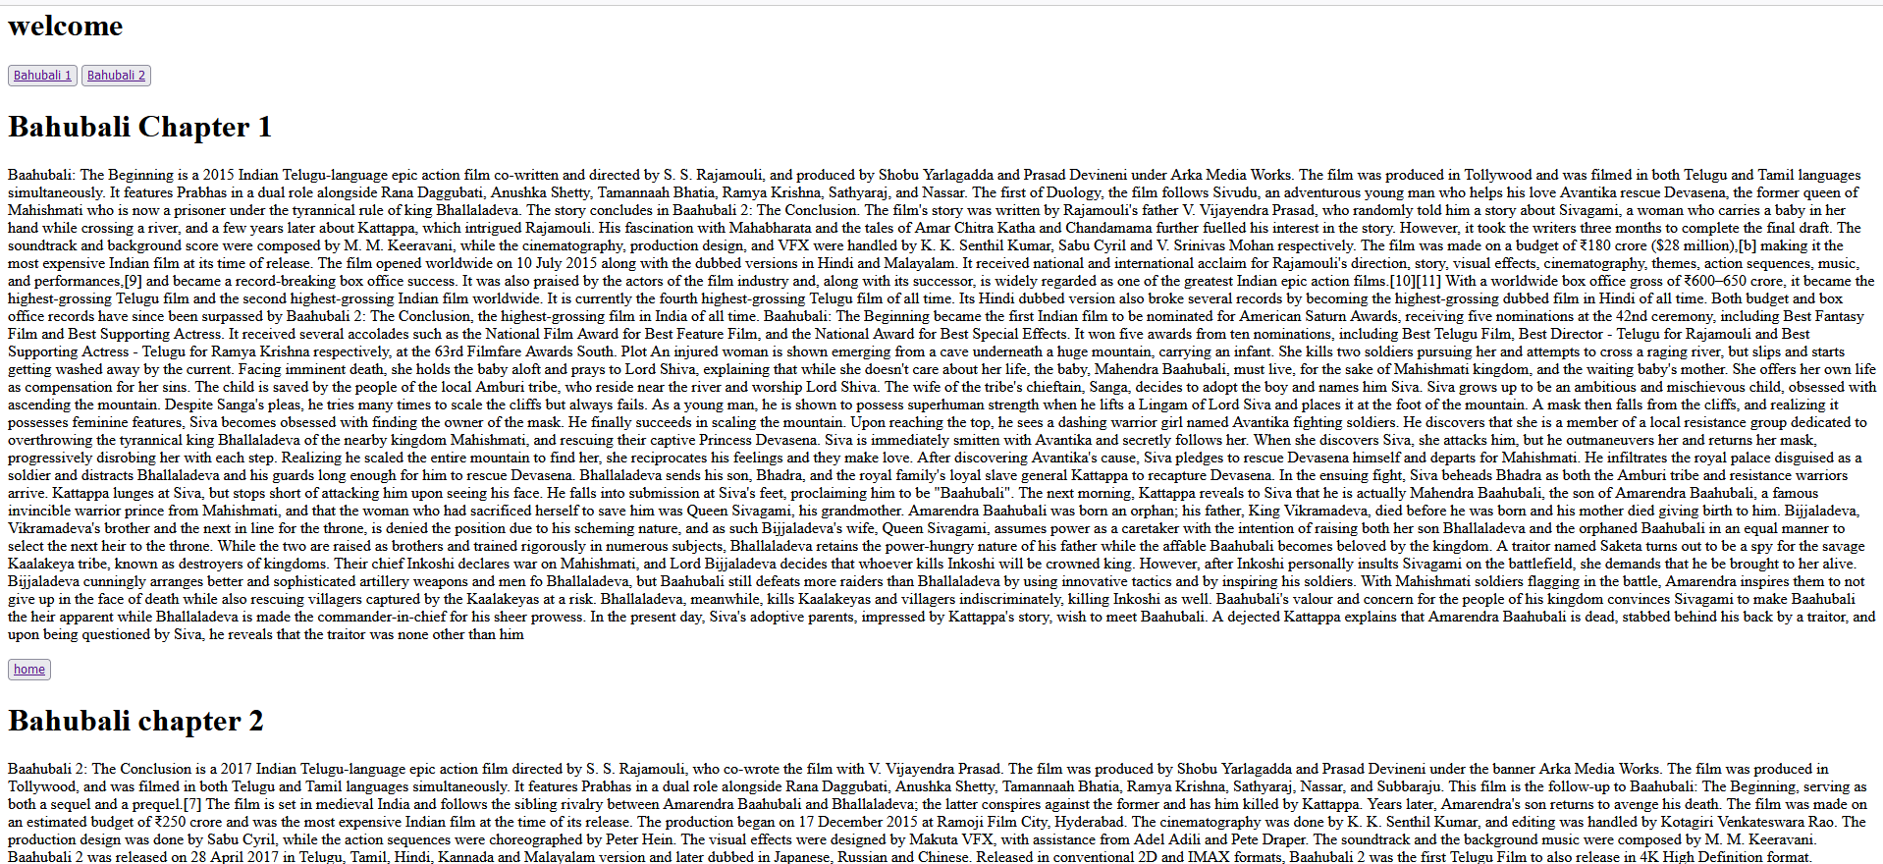

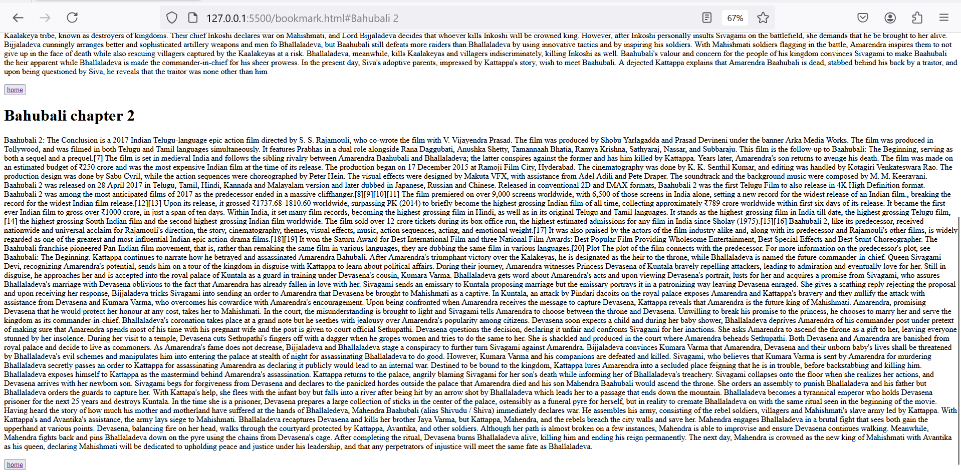

2 Create a page with iframe

<!DOCTYPE html>

<html lang="en">

<head>

<meta charset="UTF-8">

<meta name="viewport" content="width=, initial-scale=1.0">

<title>iframe</title>

</head>

<body>

<center>

<iframe src="/respons.html" width="300" height="300" name="iframe1" ></iframe>

<iframe src="/respons.html" width="300" height="300" name="iframe2"></iframe>

<br>

<a href="https://en.wikipedia.org/wiki/HTML" target="iframe1"><img src="photos/html pic.png" alt="" width="100" height="100"></a>

<a href="https://en.wikipedia.org/wiki/Pawan_Kalyan" target="iframe1"><img src="photos/pk.jpg" alt="" width="100" height="100"></a>

<a href="https://play.google.com/store/apps/details?id=com.instagram.android&hl=en_IN" target="iframe1"><img src="photos/insta.jpeg" alt="" width="100" height="100"></a>

<a href="https://en.wikipedia.org/wiki/JavaScript" target="iframe2"><img src="photos/images.png" alt="" width="100" height="100"></a>

<a href="https://en.wikipedia.org/wiki/Sreeleela" target="iframe2"><img src="photos/sree lela.webp" alt="" width="100" height="100"></a>

</center>

</body>

</html>

